Urban Planning in Developing World: Which Alternative for Poor Cities?

Jean-Claude Bolay, EPFL (Swiss Federal Institute of Technology, Lausanne, Switzerland), Professor and Director of Cooperation
jean-claude.bolay@epfl.ch, adress : CODEV, Station 10, EPFL, 1015 Lausanne, Switzerland, tel. +41/79/57021.48

Abstract

The efforts made to plan cities in emerging and developing countries are confronted to multiple issues, especially in small and middle-sized cities, which can be considered as poor through several criteria: socio-economic level of majority of population; low levels of public investments, weak quality of local administration, and large dependence of external donors.
Following several authors, one of the main reason is that philosophy and methods of urban planning applied to these specific contexts are directly reproduced from a Western tradition, which does not correspond to the local and national context in terms of needs, priorities and organization of the financial resources. The cases of Koudougou, a medium-sized city in one of the poorest countries in the world, Burkina Faso, with a population of 115.000 inhabitants, and of Montes Claros, an industrial blooming city of 360.000 inhabitants in Brazil, one of the most dynamic emerging countries in the world, will give the opportunity to make comparisons in order to understand concretely which and how these deficiencies are translated in an urban context. And foresee, more globally, alternative models of urban planning better adapted to medium-sized cities, focusing on the intermediation with their environment, in the perspective to offer new instruments of urban planning able to tackle in an efficient way the main constraints of their urbanization: growing population; territorial extension and fragmentation; environmental contamination and health; poverty and social exclusion, urban governance.

- Between theories and praxis, is urban planning more than an instrument of management ?

Urban planning is both a technique and a method of the observation and analysis of spatial, material and human reality. It is also a vision of what the city will be in the near and distant future. It is known above all by its projective and operational actions. Beyond that reality, indirectly, urban planning is also under the influence of theories and reflections which have, along the decades, consider and analyzed the city transformation and the urban mutation of the world. Discourses evolved, in the same manner that reality changes, going from the city to the urban, according to Françoise Choay (1999). Paquot et al (2000) underlined the apparent contradiction between the normativity of a globalized urbanization, following similar models, and yet in the complex ambiguity of a gigantic heterogeneity, born of distinct local and national histories, of social practices, and of natural, climatic, geographic environments. This complexity must be taken into account in our discourse on the city and urbanization. In the words of Harvey (2012), cities are the place where people of all kinds and all classes gather, willingly or unwillingly, to produce a constantly changing common life. These perspectives, from this point of view, allow us to keep some generic elements, which also apply to the South: The city is first and foremost a social system (Kilcullen, 2012), characteristic of modernity made of societal interactions and techniques (Bolay, Kern, 2011). And the city is changing under the influence of social, economic and technological transformations, forming an environment that is both natural and constructed, a form of urban ecology, confronted by endogenous and exogenous conflicts of interest. Its socio-spatial dimensions are polymorphic, variable and dynamic (Brenner & Schmid, 2014), making it impossible to give it an unambiguous definition, accepted by all. As stated in Scott & Storper (2013), the debate is endless because, based on a multi-dimensional subject and on continuous transformation, different currents of thought confront each other, some to deny the prevalence of an urban singularity, others to decipher the different characters: global city, neo-liberal city, creative city, ordinary city, and post-modern city. Certain general trends must nevertheless be remembered; as this is a global phenomenon that now massively impacts emerging and developing countries. It is first the synergy that exists between economic development and urban development, cities being, at the global level, high-tech hubs, driving forces of contemporary economics (OECD, 2006). Although these trends may be more diffused in highly industrialized countries with dense and diverse networks, they remain significant in many developing countries, with a city, usually the capital, sometimes accompanied by two or three large agglomerations, which polarize all the elements of modern technology and economic attractiveness. Infrastructure density and the sophistication of services are all assets, regardless of the country or regional context, which reinforce the centrality of the city, its dynamism and its social interactions.
This theoretical debate tends to delineate the scope of knowledge about the city, its past and present (Wheeler, Beatly, 2014), and will inevitably affect the level of planning, based on the precept that urban planning marks the translation of concepts in approaches and methods, with impact when the transfer of these theories, essentially of western origin, are applied to "other societies".
Urban planning should be understood as the prospective achievement of theories aiming for real transformation in its material as well as social, economic, environmental, and political dimensions. Planning itself is not considered a science but rather a method applied through technologies adapted to needs in the field, based on precepts often not clearly defined, but guided by instruments capable of spatially and materially organizing the distribution of individuals, their activities, goods, services, facilities and equipment in a territory that is clearly identified and limited for geographical and administrative reasons. Urban planning takes into account the potential and limitations of the natural (spatial and environmental) and human entity in question, including in its analysis the causes and impacts of the dynamics that affect the transformation of the city and its people.
The difficulty encountered with urban planning is that it is based more or less explicitly on different disciplines (architecture, urbanism, engineering, economics, sociology, public management, etc.), without rigorous obligations to refer to, and with many professional practices generally used as a basis in periodic and repeated exercises. A contrasting critical reading, forwards and backwards, is needed to understand: first, explicit or implicit links with various theories relative to city and urban societies; secondly, the anchoring points between a) the intentions highlighted by urban planning, the operations planned and the resulting implementation, and b) the procedures followed and the instruments used for their application. Using real concrete cases, in specific local, regional, and national contexts, the results of such planning processes will reveal their direct and indirect impacts on urban society, and the influence that these methods, instruments and activities have in the configuration of territorial and societal transformations. Examining the implementation and outcomes of real cases of urban planning should lead us to review urban planning, in its precepts, its methods and its applications, based on social, spatial and environmental reality, so as to make available to urban stakeholders useful tools that will help to provide sustainable solutions to urban problems that confront urban populations, in their entirety (as these problems are repeated in almost all towns in developing countries) and in their characteristics (as these problems are expressed in a particular way in each context, depending on the history of places and people, of constraints, and of current and future potential).

- Global South, urbanization and planning

First, it appears that the results of urban planning, as applied in emerging and developing countries, whether in Africa, Latin America, or Asia, only partially address the real problems facing urban populations. It is partial on the territorial level, covering only certain parts of the city, generally abandoning precarious housing neighborhoods, areas poorly regulated by law, and peripheries. It is biased on the socio-economic level, focusing primarily on the areas invested in by the privileged social actors of urban society, on the basis of their financial status, their relations to power, or even their community or ethnicity. Second, it appears that there is a caesura between urban policy makers, planners and residents. And this is largely because the fundamentals of planning were built in the North and then transferred to the South, without having been redesigned on a clear basis, but simply adapted to other physical, political and financial constraints.
Devas (2001) concluded from a comparative study conducted in nine cities of the South that in these cases overall, the standard chosen in infrastructure, equipment and buildings were totally unsuitable to the conditions of the poor, but that they formed a perfectly workable system of regulation by individuals with power, whether economic and/or political. And this is explained, according to Edensor & Jayne, in their introduction to the book "Urban theory beyond the West" (2012), by the fact that the methodological and technical discussions are dominated by Europe and North America. In this perspective, cities of the South are almost always considered less "modern" than Western cities. Yet cities in the South are gradually, and at an extremely rapid pace, inserted in the world of economic globalization. This economic and political integration of countries less marginalized than 20-30 years ago had the effect of commodifying even more the relationship between urban society and its territory, by investment priorities (public budgets facilitating the emergence and the strengthening of private operators), by the privatization of many collective services (water, energy, transportation, culture, public spaces, to name only the most obvious sectors). For Watson (2009), demographic and territorial growth of cities in the South inevitably causes a concentration of poverty and social, economic, but also spatial inequalities in cities. And urban planning, as applied in South Africa and in many other emerging countries, is not able to apprehend with anticipation and to solve a multitude of intertwined problems, between on the one hand the local needs, of each family, of each community, of each neighborhood, and on the other hand the production by the specialists of planning based on the entire urban territory, but with inexplicit priorities.
Precarious living conditions, at different levels, are reflected by a continuous expansion of slums on the fringes of the models adapted by policy makers and planners, but central to urban issues, by the increasing number of people living there, by the key problems to be addressed to vision and implement a more inclusive and coherent city. As expressed by Roy, the slums reflect both a territorial exclusion, through the lack of equipped spaces accessible to the poor, and the tensions arising from the occupation by the poor of land that sometimes becomes very attractive for the market development of the city (Roy, 2004). Which does not prevent, with very few planning and realizations, the inhabitants of the slums to greatly contribute to the economic and social dynamics of the city: job creation, income generation, community organization, and social and political participation. Also according to Watson, the question is twofold, first the models that inspire these professional practices come from the North, based on totally different socio-spatial contexts; on the other hand, planning is primarily viewed as an implementation of future territorial interventions, in a purely technical posture, with little concern for local urban history, the players involved, the interests at stake and, more generally, a societal vision taking into account all of the urban community, in its various components, especially the poor who, as is often the case in cities in South, represent the majority of citizens. The result is often that investments that are often poorly targeted and do not address the crucial questions that the majority of urban dwellers are facing. The question arises in terms of equipment choices to focus on, but also, and most often, in terms of conditions of accessibility, as costs are not adapted to the financial conditions of the most underprivileged segments of the population. These changes have induced increasingly marked urban land fragmentation, the gentrification of neighborhoods according to their level of equipment, and a socio-economic segmentation of the functions and uses of the city. The alternative, according to Yftachel (2006) would be to question five key dimensions of urban development: land-use and its allocation criteria; the policies put in place to fight against segregation; decision-making procedures, in a way that adapted forms of social participation fight against exclusion of the urban poor; the consideration of the socio-economic conditions of urban dwellers as a whole and particularly groups in the disadvantaged population; as well as the financial impact of urban transformations, especially in terms of increasing the value of land and property of rehabilitated neighborhoods. Classic planning procedures, as believed in the 60s, are no longer appropriate. It can no longer be designed in a linear and progressive perspective, insofar as it applies to rapidly changing territories, whose evolution is often misunderstood. It must, on the contrary, accept a certain level of uncertainties, which, to be understood and accepted, need to be integrated into the planning process itself, by a communication and collaboration effort between stakeholders (Woltjer, 2000).
Bearing in mind the specificities of the majority of cities in the South, the first variable to consider in appropriate planning in these contexts is the fight against urban poverty (UN-Habitat, 2010) in its different facets and consequences at various levels. Tannerfeldt & Ljung (2006) emphasize that urban poverty is relative, considering the local context and the social and economic inequalities. Financial and economic criteria are not the only ways to characterize urban poverty. In addition, indicators based on health, education, environmental quality, violence and insecurity, represent a multitude of risks that these poor families must confront. Tacoli, McGranahan and Sattethwaite (2015) designate urban sectors where the poor are systematically marginalized: insecure tenure, poor quality housing and a lack of public provision for infrastructure. Which explains that, faced with these shortcomings, residents of precarious districts must cope alone to solve these basic needs. A significant number of variables must be included in the planning process, taking into account interactions between social, ecological, economic, political and administrative dimensions. This should lead us to think of urban planning as a creative approach, innovative, ready to face the unexpected, and not as a routine approach doomed to failure (Grunau and Schönwandt, 2010).

- Poverty and urban management

This reflection is posed urgently and with high priority when it comes to cities located in emerging and developing countries; in particular with respect to small and medium-sized cities (Bolay, Kern, 2016). Overall, these are the areas that suffer the highest rates of population growth; it is their authorities who suffer most from the lack of financial and human resources to be able to anticipate and address these issues. And these are the inhabitants, at local and regional levels, who suffer the consequences in terms of human and material precariousness, contamination of natural resources, informality of economic activities, a malfunction in the process of decision-making and governance. And it is this urbanization that will in the coming decades be put under increasing pressure, knowing that 95% of urban growth will primarily impact emerging and developing countries, and first of all in intermediate cities. Depending on the regions of the world, the process of a rapid urbanization is directly linked with a growth of poverty and more socio-economic disparities. For Mike Davis (2006), slums are the prominent feature of contemporary urbanization. He focuses on its negative aspects such as violence, insecurity, informality and poverty, which, in his opinion, are the result of the economic power relations of a globalised world. Around one billion of people in the world live in this kind of poor settlements (Bolay, Chenal, Pedrazzini, 2016). The figures collected by the United Nations on this issue in 2011 (UN-HABITAT, 2010) show that their expansion varies widely according to regions of the worlds. If, on a global level, about 32.7% of the world urban population live in slums in 2010, this concerns 61.7% of the sub-Saharan population in Africa, 35% in Southern Asia, 31% in South Eastern Asia, when 23% in Latin America and the Caribbean, and 13.3% in Northern Africa. With, as demonstrated by Mboup (2004), the relative significance of the individual identification parameters of slums on a global level: lack of secure tenure 70%; lack of durable housing 65%; lack of sufficient living space 60%; lack of improved sanitation 50%; lack of improved water 20%.
All these characteristics allow us to speak about “poor cities”, meaning cities in Southern countries confronted with different forms of precarity, having a high percentage of dwellers living in sub-standards conditions (in terms of incomes as in terms of habitat and access to services). The situation is particularly critical in intermediate cities, between 20.000 and 500.000 individuals. On one side because they include around 50% of the whole urban population in the world (United Nations, 2014), on the other side because they represent the fringe of cities with the higher level of urban growth. In front of that, theses “ordinary cities” (Robinson, 2006 ; Parnell & Robinson, 2012) are generally not under the political attention of the central government, and their public budget are relatively low to tackle all the urgent questions to resolve and investing for the future. And priorities of investments, as we shall see in the 2 case studies, are not decided based on a rigorous diagnostic involving a process of urban planning at long term, but more in relation with opportunities or under pressure of powerful stakeholders, inside the city or as powerful outsiders.

- Urban planning in practice: The cases of Koudougou, Burkina Faso, and Montes Claros, Brasil

At first view, these 2 cities have few points in common. Koudougou, a little bit more than 100.000 dwellers, is located in Burkina Faso, one of the poorest countries in Africa (Bolay, 2015); when Montes Claros, 400.000 inhabitants, is considered as an intermediate city in the State of Minas Gerais in Brazil, one of the most powerful emerging countries (despite the crisis) in the world (Bolay, 2016).
But some convergences exist between the 2 cities, too. Both of them play an important and growing role of intermediation linking the city, their hinterland, the region, and other cities in the country, even at international level (more than all through industry in Montes Claros, and with a strong support of external agencies of cooperation in Koudougou).
Koudougou is the capital of the province of Boulkiemdé and represents a pole of activities for this regions, with its big city’s market, shops, banks, province and local administrations, and number of delegations of national ministries, university, among other assets. The city is a real platform of exchange, with the agriculture producers of the region, and with Ouagadougou, capital of the Burkina Faso, only 100 km from there with one of the rare excellent roads in the country. These elements explain in large part that urban growth of Koudougou stays largely dominated by a continuous flow of rural immigrants. In turns, the city of Montes Claros, even not capital of the State of Minas Gerais, is the main urban pole in the Northern part of this State. Having during decades be the center of distribution of agriculture products from this region, these activities continue, but gradually overtaken, since the 1970’, by the establishment of many industrial enterprises, national and foreign branches, and more and more by new private and public services for the whole population of Northern Minas Gerais (universities, hospitals, shopping centers, banks and so on …).

Fig. 1 Suburb of Koudougou (photo JC Bolay, 2014) | 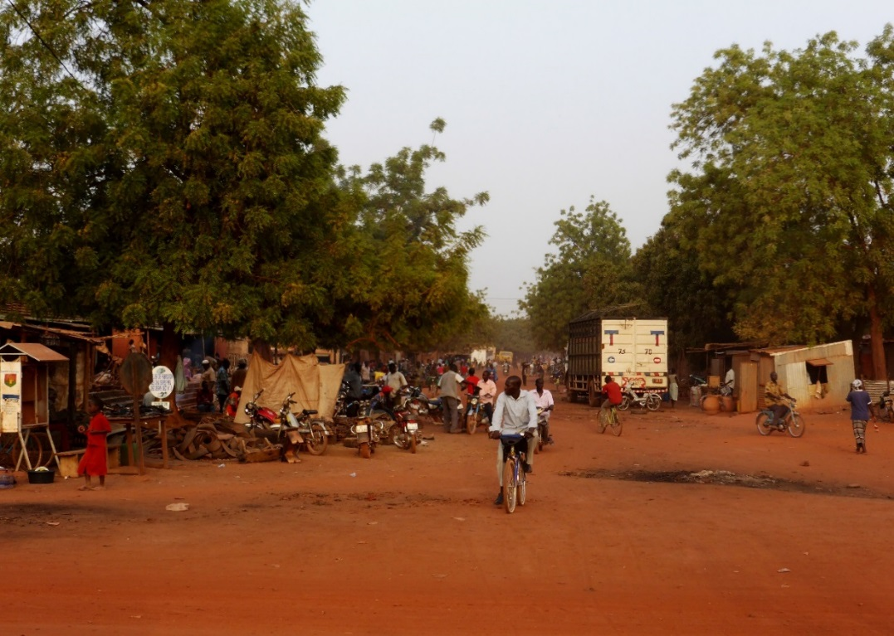

Fig. 2 New social housing settlement in Montes Claros (photo JC Bolay, 2015) | 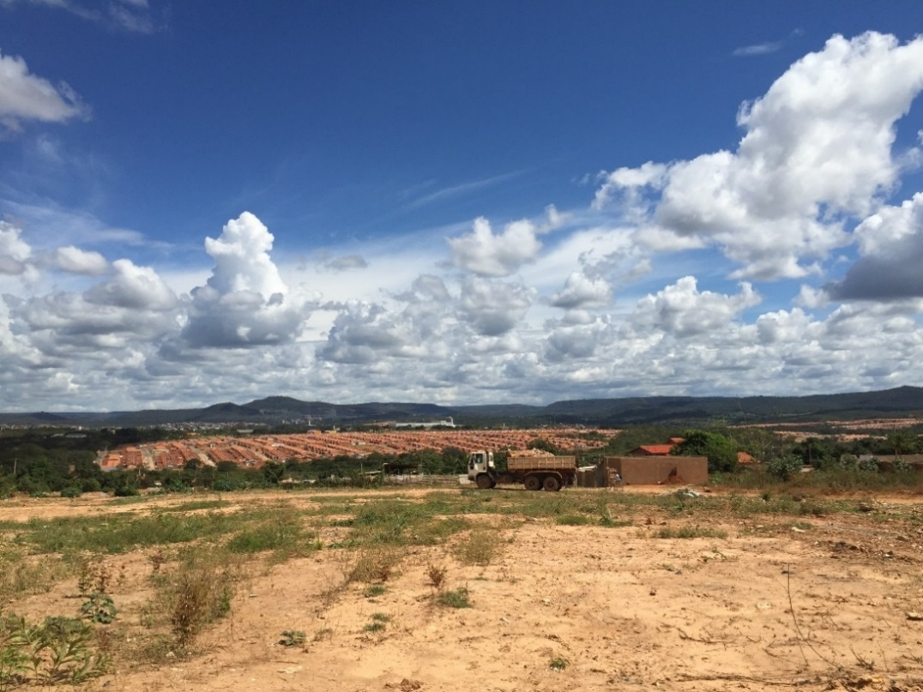

  - Lessons learned from Koudougou

There have been many plans drawn up for the city of Koudougou over the past fifteen years − some with an overview as are the local development plans or master plans − or more sectoral as the strategic sanitation plan or strategic household waste plan. Their advantage is that they give a picture of the investments to be made to improve the situation in the municipality. Their great weakness is that they are not executed because they are out of step with the financial means and the competencies of the municipal administration. At best, they serve to reassure donors during financial negotiations. We face this fundamental contradiction as we face the objectives of urban planning. What do the stakeholders say? What are the intentions of this urban planning that has been largely developed in Burkina Faso since the 2000s, in line with the strategies of international donors that support the government in its development efforts?
The plans do not meet the traditional goals to develop the future of Koudougou, but mark the ambitions of the authorities facing the organization of the territory. And it is clear that challenged by the multitude of problems to solve, it is difficult, both politically and technically, to set priorities in terms of areas and sectors. Everything immediately becomes a priority, without criteria that justifies choices made. And consultation frameworks between policy makers, operators and population − if they are desired and recognized useful − are gradually set aside, for lack of resources and available time. In fact, much focus is put on the tool, implementing a proven technicality (that of consulting firms mandated to do this), and on the indicative outcomes − and very little on the approach and the objectives of the application of this instrumentation.
The second very large problem encountered is related to the conditions of the production of urban development plans, in Koudougou as in other cities of Burkina Faso. Three stumbling blocks: the first is that these local plans are decided by the national government and "imposed" on the municipalities; the second comes from the fact that the municipal administration of Koudougou, like many Burkinabe cities, is under endowed with competent personnel, and is thus unable to participate in the design, the supervision and the monitoring of this production of local plans. Neither does the glaring lack of financial resources allow the Municipality to implement this planning that takes more than wishful thinking and is primarily used for advocacy with funders, rather than as a guide in an assured control of local urban development.
And the conclusion of all the experts agree that planning tools exist but are not used as such, and prove to date to be unnecessary. Indeed, it is revealed by the study, they are diverted from their original purpose and become an object for urban marketing and communication with donors, since all donors think it essential that each city where they intervene includes planning. In the words of one amused speaker: the plan is a catalog of all that must be done in the municipality, donors choose what they want to finance! Two rationales conflict with the overall interests of coherent and sustainable urban planning: first, the aspirations of foreign donors, to which national and local authorities will submit, are a priority and guide investments; second, the will of national and local political leaders is to make their mark on the territory by occasional symbolic "gestures" of their presence in power, rather than stewardship over the long term

  - Lessons learned from Montes Claros

Montes Claros is a perfect example of an intermediate Brazilian city. While it would be incorrect to describe it as a poor city, the urban population is highly segregated; one third of the city’s population is poor, and the wealthy - who represent 20% of the population - control 66% of the local wealth. This fragmentation of the social fabric is also reflected in the more than 140 unregulated neighborhoods and 50,000 people living in makeshift housing conditions.
In addition to these socio-economic and territorial disparities, two other major problems exist. The first is the depletion of natural resources due to advanced deforestation and periodic flooding of central neighborhoods, a problem that largely results from the construction of new housing developments (social and luxury), wherein the environmental impact of these forms of urbanization, which have become increasingly popular in the past 20 years, are not fully considered. The second is the lack of regional integration of the municipality’s rural hinterlands. These areas, where services and telecommunications are still rudimentary, are gradually being abandoned as purely agricultural region and progressively transformed in new peri-urban settlements.
To address this situation, the local authorities are in the process of developing a new master plan. As such, the plan aims to create a sustainable city, including a right to urban land, housing, infrastructure, services, transport and employment for everyone.
The critiques lean in two directions:
First, the implementing of decisions made by the council falls on technical teams and administration members who have neither a guaranteed job in the long term, nor attractive salaries. Secondly, political changes in the city’s administration have direct political repercussions on the continuity of urban alternatives, with each new mayoral team seeking to set itself apart from its predecessors and to “leave its mark”.
The current process raises many issues. To begin, it is impossible to discern the authorities’ medium- and long-term vision, which would be helpful in streamlining the urban planning. Furthermore, the authorities’ perception of Montes Claros is biased as it only takes into account the dense areas in the city center. The rapidly growing outskirts and suburban areas are still disconnected from the rest of the city and are poorly integrated in this prospective exercise. In the future, Montes Claros must be seen as an urban hub for northern Minas Gerais, in a kind of urban/rural/interurban interplay that involves environmental, social, educational and housing issues. All neighborhoods and people cannot be dealt with in the same way; specific needs and priorities must be taken into account. While there is undeniably cooperation with national and regional authorities in the implementation of the current plan, it is not a participatory master plan in the eyes of many respondents. Considering the current process is that, once completed, the master plan should be supported by enabling legislation. Without it, the plan cannot be fully functional.
This ongoing process may be can be seen as an associative process, but not a veritably participatory one. City Hall has indeed teamed up with private agencies and representatives from different sectors (universities, representatives from the economic community, and the ad hoc committees of the City Council), but without including the public in the initial phase of the process. Instead of collecting opinions and request of the population, it is only now in the final phase that the provisional results, which will determine the guidelines for future planning, have been presented and discussed in the more urbanized areas of the city. This exclusive approach has received considerable criticism from "outsiders", particularly volunteer organizations and social groups, who were not invited to participate in the process from the beginning. For them, this denotes a certain authoritarianism on the part of the public authorities, who have not seized the opportunity the new plan affords to engage in an open dialogue with the public to better understands its needs, desires and vision of their urban future.
Though Montes Claros cannot be described as a "poor city", it can be described as an intermediate city that, like many other cities in Brazil, is experiencing the kind of unbalanced growth that is typical of what one can see in cities around the world. Brazil has become one of the most segregated countries in the world, an emblem of economic globalization in a growing struggle between global regions and cities (nationally and internationally) and strategies to improve social cohesion and cultural/economic integration, reflected politically in terms of urban planning.

- From and towards the South : Rethinking urban planning

Urbanization in emerging and developing countries is today an irreversible trend of the transformations that shape the world, and this regardless of the country where one looks, and whatever the city concerned. Driven by mass migration of rural populations to urban centers and by natural growth that is still very strong, sustainable urban development is a question that confronts all cities, in priority in Africa and Asia, and in all small and medium-sized cities of Southern countries, with identical problems: organizing the planning of territory in continuous demographic and spatial expansion, and, in parallel, doing its best with limited financial and human resources. If the very large cities, national capitals or economic and political hubs enjoy comparatively more marked attention from governments and funders, the smaller sized agglomerations remain neglected and almost invariably face a multitude of glaring necessities, with no real means to respond to social demands for investing in infrastructure and community facilities that match the identified needs. These questions remain unanswered, addressed mainly in an emergency or according to the allocations provided sporadically by national governments or by foreign financiers.
This urban context of great insecurity and uncertainty about the future of these small and medium-sized cities allows us to speak of "poor cities”, not only because a large part of their citizens actually live on the edge of destitution, but also because urban authorities are poorly equipped in means to assume the investment that would be needed to improve the daily life of all residents.
In this context, urban planning must be completely rethought and taken out of the patterns of development models that were designed for completely different environments, being for the most part the simple reproduction of defined standards and rules implemented in Western countries by specialists whose credentials are totally foreign to global South. The major risk in this situation is that of projecting these cities on a basis that will serve only the interests of a minority of citizens, favoring the most advantaged in economic and territorial development, and leaving the modest population on the margins, those living in informality and in the most underserved neighborhoods. But it also represents an extraordinary opportunity to think about the future from what exists, taking into account the real resources, not only financial but also social, to devise and implement urban planning with the goal to fight against poverty and invest in equipment that has a sustainable impact on the living conditions of the poor.
As such, the analysis carried out in Koudougou, Burkina Faso, is very instructive. Provincial capital at 100 kilometers from Ouagadougou, Koudougou is a commercial and political center of a large rural area, but it has also long been considered as a rebellious city, unwilling to obey the requirements of the Burkinabe central government. In Koudougou, as in many intermediate African cities, the urban planning process is exogenous, not really consistent with the requests of the people, nor with the human, material and financial resources of the city, and therefore rarely applied.
This is easily explained when we know that urban planning in its design, is initiated as part of a collaborative framework between the central government and foreign donors. The initial diagnosis is made by quality professionals but who are disconnected from local administrative and social realities. In fact, it is a census of all needs to be met, but without a guidance manual! How then the facilities to be created whose costs are more than ten times that of the annual municipal budget reserves? In fact, plans produced in this context do not serve to guide local authorities in the current and future development of the urban territory. Neither are they an instrument of dialogue between the said authorities and the population. On the contrary, any consultation with the community that does not result in expected and desired deliverables will strengthen the distrust, or even defiance towards public, political, and administrative powers. At best, the plans, losing their principal essence, become promotional tools, pure marketing products, a catalogue of intentions of penniless communities at the mercy of the donors’ desideratum, whether they be State or foreign cooperation agencies.
With a population of nearly 400,000 inhabitants Montes Claros, in Brazil, with much more resources than in Koudougou, cannot be described as a poor city, but the urban population is highly segregated; one third of the city’s population is poor. This fragmentation of the social fabric is also reflected in the more than 140 unregulated neighborhoods. In addition to these socio-economic and territorial disparities, a major problem exists: the lack of regional integration of the municipality’s rural hinterlands. These areas, where services and telecommunications are still rudimentary, are gradually being excluded of urban and regional planning.
Today, the municipality is facing the issue of social exclusion, with an increasing proportion of the urban population living in economic insecurity and relative marginalization, both geographically and socially. These are key issues for a comprehensive urban plan whose aim is to not only act spatially. This ongoing process, which will determine the guidelines for future planning, is primarily focused on the more urbanized areas of the city.
This distortion of urban planning is dangerous, since it destroys any coherence in a more regional perspective, both in establishing priorities in infrastructure and equipment to realize, in the economic and social sectors to be favored, as in the implementation timeframes, without any possible guarantee that things will be done on time, potentially creating more long term disorganization than anything else.
Urban planning in developing and emerging countries must be entirely reconsidered. The essential point − too often overlooked − is to begin from a participatory diagnosis in which the actual situation of the city is examined in its various dimensions, both demographic and spatial, infrastructural, but also economic, social and environmental, permitting all the stakeholders to position themselves. This information, cartographic, as well as documentary and anthropological, will serve as the foundation for the establishment of a database that can then be fed in real time, facilitating the monitoring of "urban development" and a collaborative, up-to-date decision-making process. In parallel is the question of establishing priorities, in terms of structures to be built, but also in terms of standards, rules and plans tailored to the context, with regard to the needs identified by specialists, to requests from the different social actors, as well as the available resources, both local and from external sources. Two principles should guide this work: first, that urban investments be directly or indirectly involved in the fight against poverty; second, that an overall coherence guide the specific actions in the short, medium and long term. These precepts can only be applied if the framework conditions are respected: local and regional governments must be given the human competencies and financial resources enabling them to act. And it is not impossible if the political will is there, and is based on a legitimacy in the eyes of the population. And this inevitably involves consultation frameworks that will animate the dialogue between representatives of the population, public administration, political powers, industry professionals and other special interest groups (private sector; social, religious, and political groups; NGOs; etc.). Training plays a key role, as does communication and dialogue. And it is these same guidelines that should guide implementation. Here too there is room for innovation, starting with the social practices and deployed human dynamics, beyond any formalism, on the local and regional levels. While it is clear that it takes the technical know-how of experts of the city and businesses, we must also remember that the own inhabitants did not wait to take the place of these players − too often absent − to build their houses, build community facilities, to better manage their neighborhoods.
These vital forces should neither be overlooked, nor marginalized; they are the center of a participatory process that is not limited to the consultation but goes from conception to action. They must be integrated into the planning process and thus contribute concretely to the implementation of decisions taken collectively. Communication is also a key issue. How to learn from other cities via the Internet and increasingly frequent global exchanges on urban matters. Whether we look at the frequent international summits on these issues by the United Nations or at visits of municipal delegation between continents. If, as indicated by Campbell (2012), we learn from near and far, and learning is no longer unilateral from North to South, but also from South to South and South to North. There nevertheless remain three reservations in this regard: first, urban technological innovations, even from emerging countries, are first found in the largest and richest agglomerations; in return, small and medium sized cities remain on the margins of these innovative processes and rarely have the opportunity to apply them, for lack of means; the question of precarious housing and urban poverty is generally treated as a problem, without utilizing and applying in similar contexts the lessons learned from this situation. These views are not so arrogant as to believe that all problems will now magically be solved, but rather that we are breaking out of a vicious circle in which urban planning is not playing its role, totally disconnected from a complex and changing reality. And put forward, as an innovative alternative, a more realistic vision, more pragmatic, based on what exists and focusing the efforts of all the citizens in favor of a gradual improvement in well-being for all, giving priority to the most deprived urban citizens.

References
Bolay, J.-C. (2016). Prosperity and Social Inequalities: Montes Claros, How to Plan an Intermediary City in Brazil. Current Urban Studies, 4, 175-194. doi: 10.4236/cus.2016.42013.
Bolay, J.-C., Kern, A. L. (to be published in 2016). Intermediary Cities. In Wiley-Blackwell Encyclopedia of Urban and Regional Studies. Hoboten : Wiley-Blackwell.
Bolay, J.-C., Chenal, J., Pedrazzini, Y. (2016). Learning from the slums: the habitat of the urban poor in the making of emerging cities. Paris, Heidelberg, New York, Dordrecht, London : Springer. doi: 10.1007/978-3-319-31794-6.
Bolay, J.-C. (2015). Urban Planning in Africa : Which Alternative for Poor Cities ? The case of Koudougou in Burkina Faso. Current Urban Studies, 3, 413-431. doi:10.4236/cus.2015.34033.
Bolay, J.-C., Kern, A. (2011). Technology and Cities: What Type of Development Is Appropriate for Cities of the South? Journal of Urban Technology, 18(3), 25-43. doi : 10.1080/10630732.2011.615563
Brenner, N., Schmid, C. (2014). The “urban age” in question. In N. Brenner (Ed.), Implosions / Explosions. Towards a study of planetary urbanization. Berlin: jovis Verlag.
Campbell, T. (2012). Beyond smart cities. How cities network, learn, and innovate. London, New York: Earthscan.
Choay, F. (1999). De la ville à l’urbain. Urbanisme, 309, 6-8.
Davis, M. (2006) Planet of Slums: Urban Involution and the Informal Working Class. New York, London: Verso.
Devas, N. (2001). Does city governance matter for the urban poor?, International Planning Studies, 6(4), 393–408.
Endensor, T., Jayne, M. (2012). Urban Theory Beyond the West. A world of Cities. London, New York : Routledge.
Grunau, J.-P., Schönwandt, W. L. (2010). Dealing with Society’s „Big Messes“. In G. De Roo, E. A. Silva (Eds.), A planner’s encounter with complexity (pp 41-62). Surrey : Ashgate.
Harvey, D. (2012). Rebel cities. From the right to the city to the urban revolution. London, New York : Verso.
Kilcullen, D. J. (2012). The City as a System: Future Conflict and Urban Resilience. Fletcher Forum of World Affairs, 36(2), 19-39.
Mboup G. (2004). Slum dwellers estimates country level. In Training workshop on data and indicators to monitoring Progress towards the MDGs and the Habitat Agenda, 1-5 November, Bangkok.
OECD (2006). Territorial reviews: Competitive cities in the global economy. Paris : OECD.
Paquot, T., Lussault, M., Body-Gendrot, S. (2000). La ville et l’urbain, l’état des savoirs, Paris : La Découverte.
Parnell, S., Robinson, J. (2012). (re)theorising cities from the global south: looking beyond neoliberalism, Urban Geography, 33(4), 593-617.
Robinson, J. (2006). Ordinary cities : Between modernity and development. London : Routledge.
Roy, A. (2004). Transnational trespassings. The geopolitics of urban informality. In A. Roy, N. Alsayad (Eds.), Urban Informality. Transnational perspectives from the Middle East, Latin America and South Asia (pp. 289-317). Lanham, Boulder, New York, Toronto, Oxford : Lexington Books.
Scott, A. J., Storper, M. (2014). The nature of cities: The scope and limits of urban theory. International Journal of Urban and Regional Research, 39(1), 1-15.
Tacoli, C., McGranahan, G., Satterthwaite, D. (2015). Urbanisation, rural-urban migration and urban poverty. London: IIED.
Tannerfeldt, G., Ljung, P. (2006). More urban less poor. An introduction to urban development and management. London: Sida & Earthscan.
United Nations, Department of Economic and Social Affairs, Population Division (2014). World Urbanization Prospects: The 2014 Revision, Highlights. New York : United Nations. https://esa.un.org/unpd/wup/publications/files/wup2014-highlights.Pdf. Accessed 22 December 2016.
UN-Habitat (2010). State of the World’s Cities 2010/2011. Bridging the Urban Divide. London: UN- Habitat & Earthscan.
Watson, V. (2009). Seeing from the South: Refocusing Urban Planning on the Globe’s Central Issues. Urban Studies, 2009 (46), 2259-2275.
Wheeler, S. M., Beatley, T. (2014). Sustainable Urban Development Reader (Routledge Urban Reader Series), 3rd edition. London, New York : Routledge.
Woltjer, J. (2000). Consensus planning: the relevance of communicative planning theory in Dutch infrastructure development. Aldershot, UK: Ashgate.
Yftachel, O. (2006). Ethnocracy, Land and Identity Politics in Israel/Palestine. Philadelphia, PA: University of Pennsylvania Press.

